**Movie bank user guide**

1. Build movie bank server in Unix/Linux system
2. Install JSON-C - A JSON implementation in C

<https://github.com/json-c/json-c/wiki>

1. Install MySQL
2. Get code of movie bank (including both server and client code)

git clone https://github.com/jmpeng/movie_bank.git

1. Build server and client

cd server; make

1. Build movie bank client in Unix/Linux system

cd client; make

1. Import movie bank data into MySQL DB

The movie bank data is available in file movie_bank.csv.

Example to load the data into MySQL DB:

mysql> load data local infile 'movie_bank.csv' into table MOVIE fields terminated by ',' lines terminated by '\n' (mov_id, color, director_name, num_critic_for_reviews, duration, actor_2_name, genres, actor_1_name, movie_title, cast_total_facebook_likes, actor_3_name, plot_keywords, movie_imdb_link, num_user_for_reviews, language, country, content_rating, title_year, imdb_score, aspect_ratio, movie_facebook_likes);

1. Run server and client
2. Run server

cd server; ./movSer





1. Run shell client

cd client; ./movClient *IPaddr 5001* -- IPaddr is the IP address of server











1. Run Android client:
2. on Android Studio, click the green arrow button to run the application

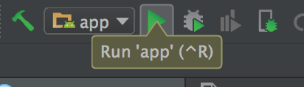

1. select deployment target and then click “ok”

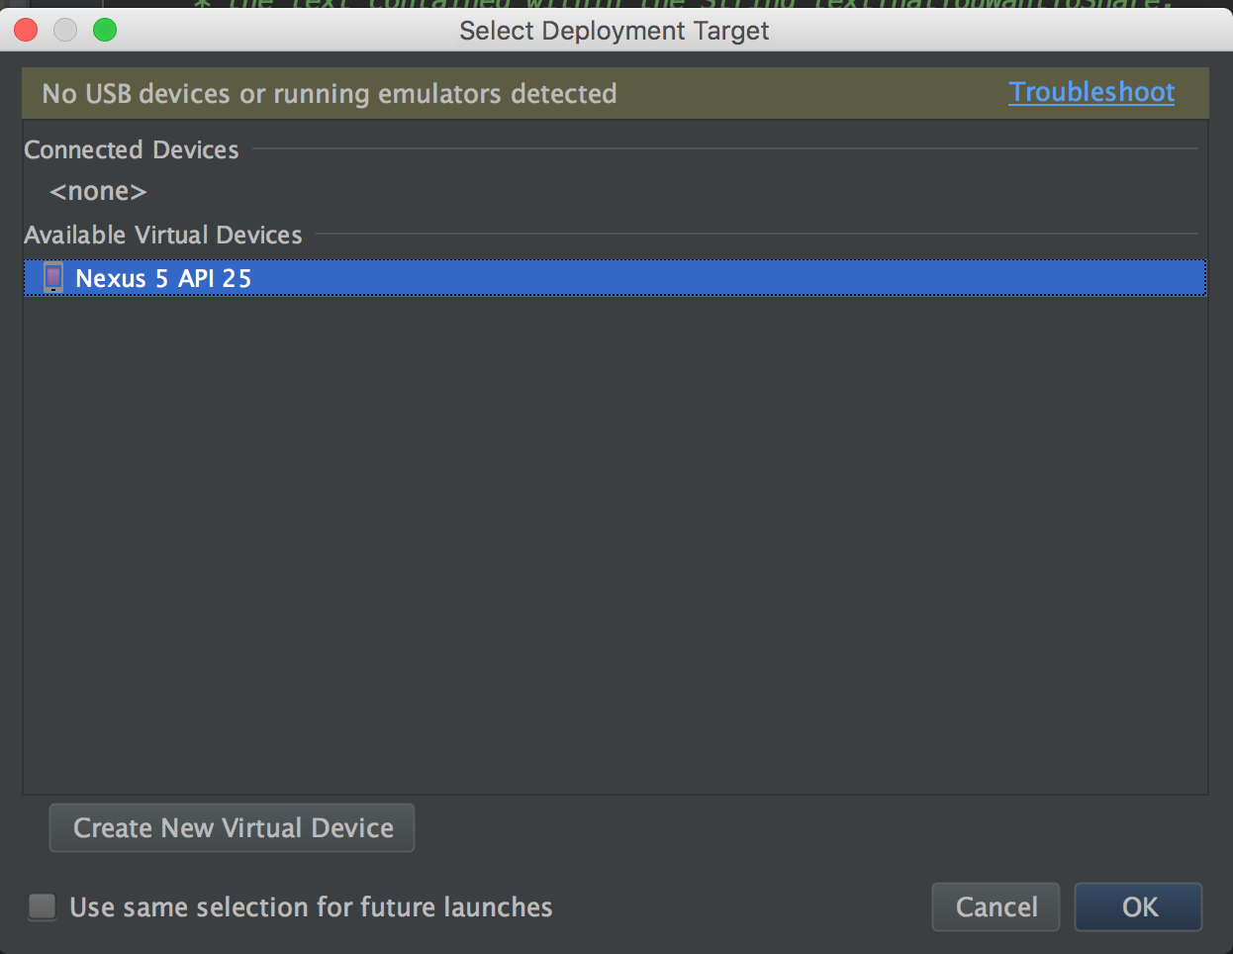

1. input keywords that you want and then click “search” button

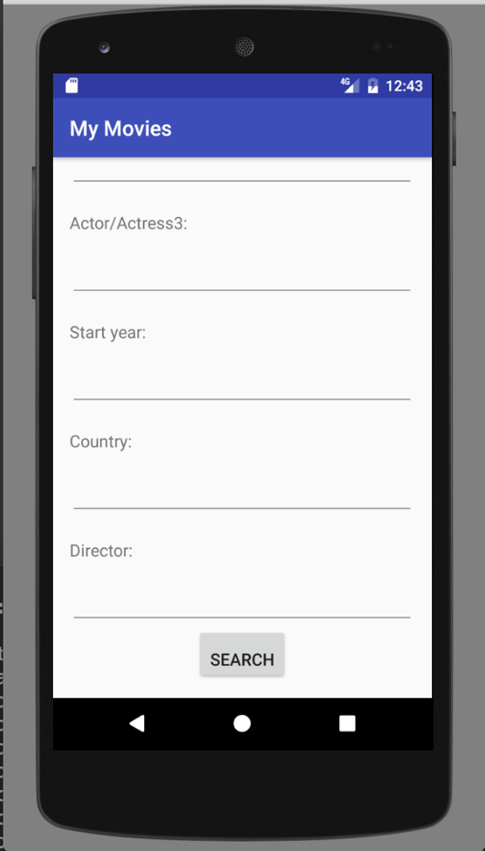

1. scroll down to load more movie records or click the link to see more details

